KUBERENETES REQUIRED DOCUMENTATION
For hands-on purpose, just install minikube and enable the Kubernetes in docker app.
https://minikube.sigs.k8s.io/docs/start/?arch=%2Fwindows%2Fx86-64%2Fstable%2F.exe+download
In K8S we have two types of nodes
1. MASTER NODE
2. WORKER NODE
Just open terminal and run minikube start, make sure that docker is running and enabled k8s.
Check by running kubectl get pods the response should be no resource found.
Components :
1. POD
2. DEPLOYMENTS
3. SERVICES
4. PV- PVC
5. SECRET
6. CONFIGMAPS
7. REPLICA CONTROLLERS
8. REPLICA SETS
Now to create a POD, just run
- kubectl run my-pod –image nginx
Now pod will be created.
What is pod?
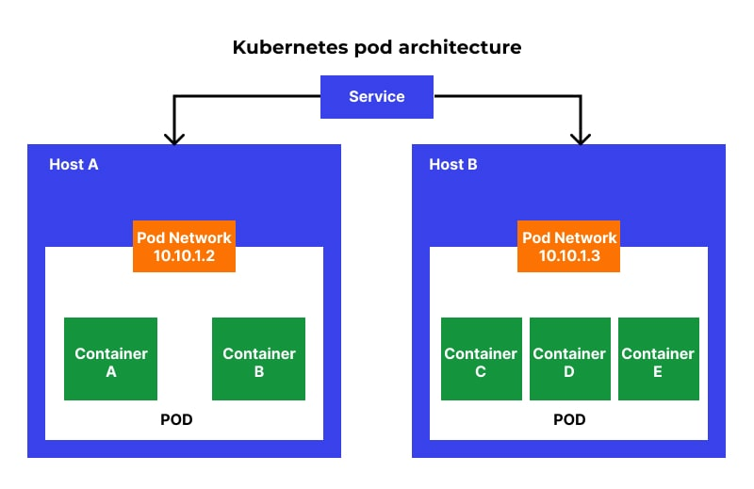
A pod is the smallest execution unit in Kubernetes. A pod encapsulates one or more applications.

Cluster = have multiple containers and we will access the clusterIP. We don’t directly deal with one container because we want high availability and these clusterIP pick any container available and will give data/application.
POD contains one container. It can have more than one, but not a recommended approach.
POD have IP address , containers have PORT address.
Always POD will be created in worker node.
To create POD
apiVersion: v1
kind: Pod
metadata:
name: my-pod
spec:
containers:
- name: my-container
image: nginx

